The Core Truth
Why Your Back Pain Might Not Be What You Think It Is
—And How to Fix It—
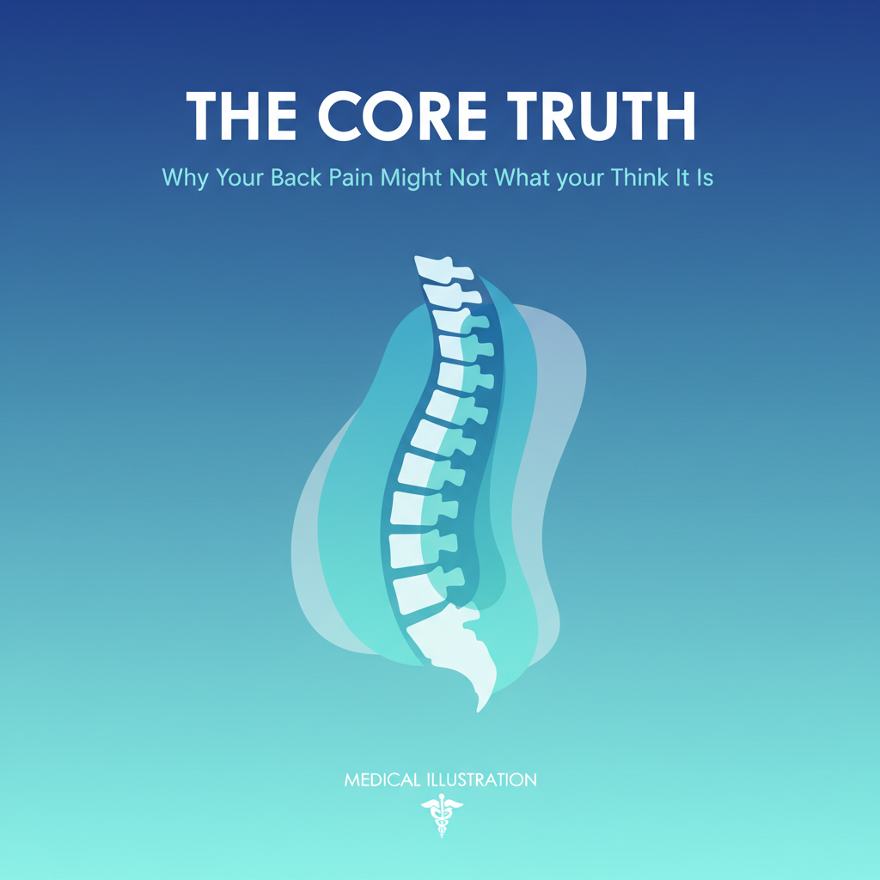
A Comprehensive Guide to Understanding Your Vertical Core
and Reclaiming Your Pain-Free Life
• Free eBook •

◆ ◆ ◆

Does This Sound Like You?
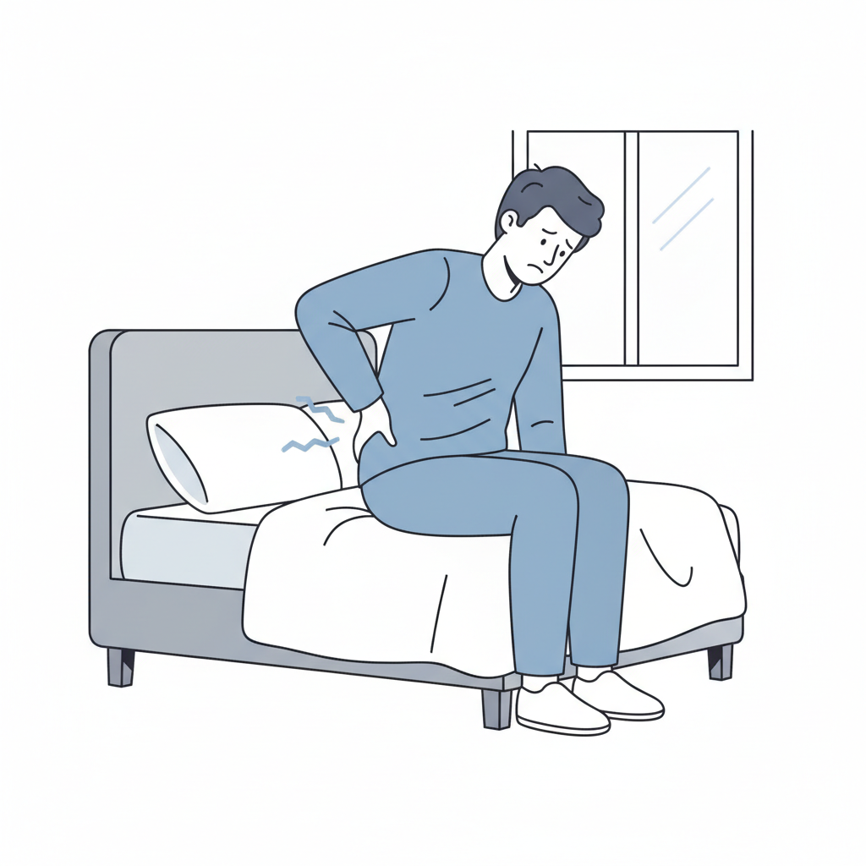
You wake up with a stiff back. You struggle to sit through a work meeting without discomfort. You miss out on activities you love—hiking, playing with your kids, carrying shopping—because your back gives you grief. You've tried stretching, foam rolling, maybe even seen a physio, but the pain keeps coming back. In the UK, nearly 31 million work days are lost each year due to back and musculoskeletal problems, costing £12.3 billion annually¹⁰.
You're not alone. Back pain affects millions of people in the UK, with approximately 1 in 6 adults experiencing some form of back pain¹, and it's often a sign that something fundamental is missing from your fitness routine: proper core training.
The good news? This is fixable. And you don't need expensive surgery or endless treatments. You need to understand your core—and learn how to train it properly.
◆ ◆ ◆

What You'll Learn in This Guide
This comprehensive guide will show you:
- What your "core" actually is (it's way more than six-pack abs)
- Why back pain happens—and how it's connected to core weakness
- How to assess whether YOUR core is functioning properly
- The exact exercises (and progression plan) that get results
- How to integrate core training into your life—so results actually stick

◆ ◆ ◆

1. What's Actually Going Wrong?

The Problem Most People Don't Realise They Have
When you have back pain, your instinct is usually to rest. Avoid movement. Maybe do some basic stretches.
But here's the truth: resting usually makes it worse.
Back pain is often a symptom of a deeper issue: your core muscles aren't doing their job. They're not stabilising your spine. They're not protecting your lower back during daily movement. And because they're weak, other muscles—like your lower back extensors—have to overcompensate, leading to pain, stiffness, and eventually injury. Back pain is the leading cause of disability in the UK¹, making proper core training essential for recovery.

Why Crunches Don't Work (and Might Be Hurting You)
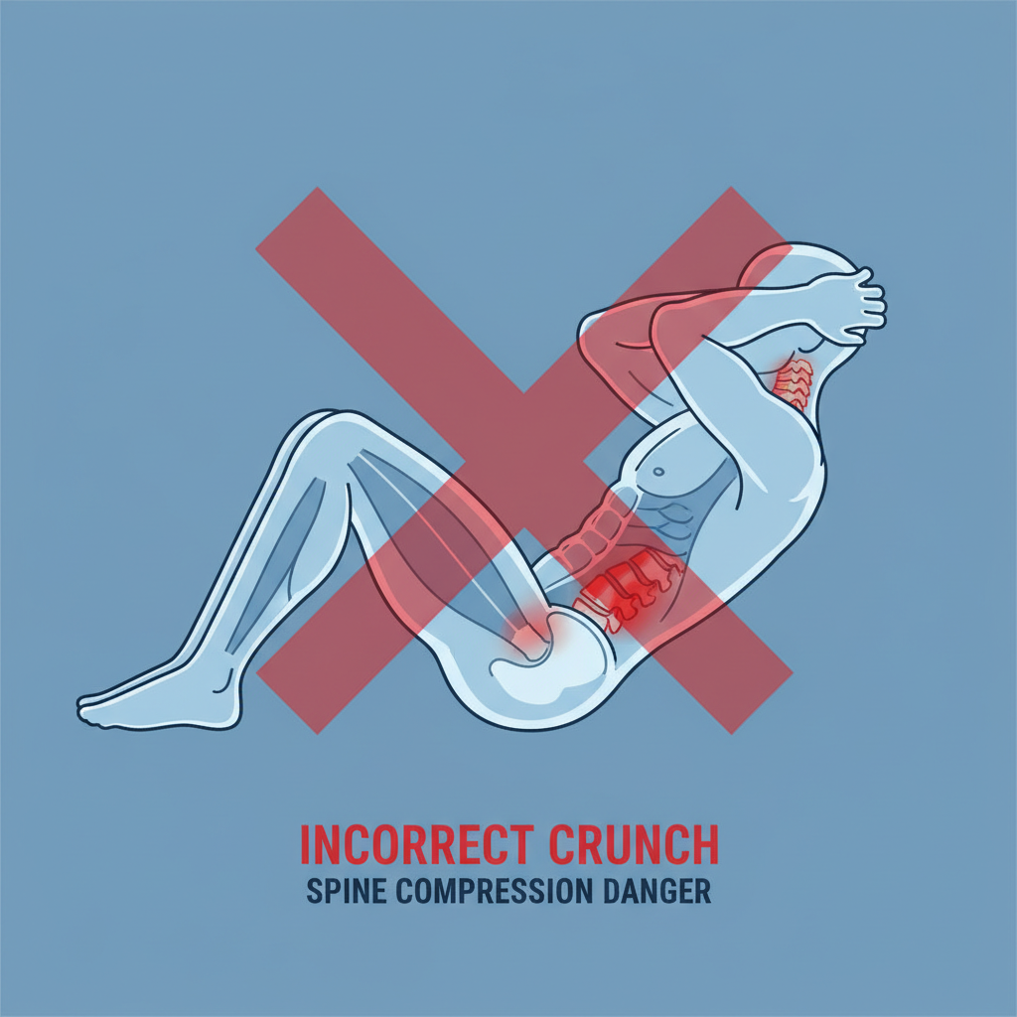
You've probably done hundreds of crunches. Maybe thousands. And they haven't fixed your back pain because crunches train the wrong muscles in the wrong way.
Traditional ab exercises focus on the superficial rectus abdominis—the muscle that creates a six-pack appearance. But they largely ignore the deep stabilising muscles that actually protect your spine. It's like building a house with a beautiful exterior but a weak foundation.
Worse, crunches can actually reinforce poor movement patterns and worsen existing back pain by compressing your spine repeatedly.

Introducing the Vertical Core
Your "core" isn't just your abs. It's a sophisticated system of muscles that runs vertically along your body—from your pelvic floor all the way up through your deep spinal stabilisers to your deep neck muscles.
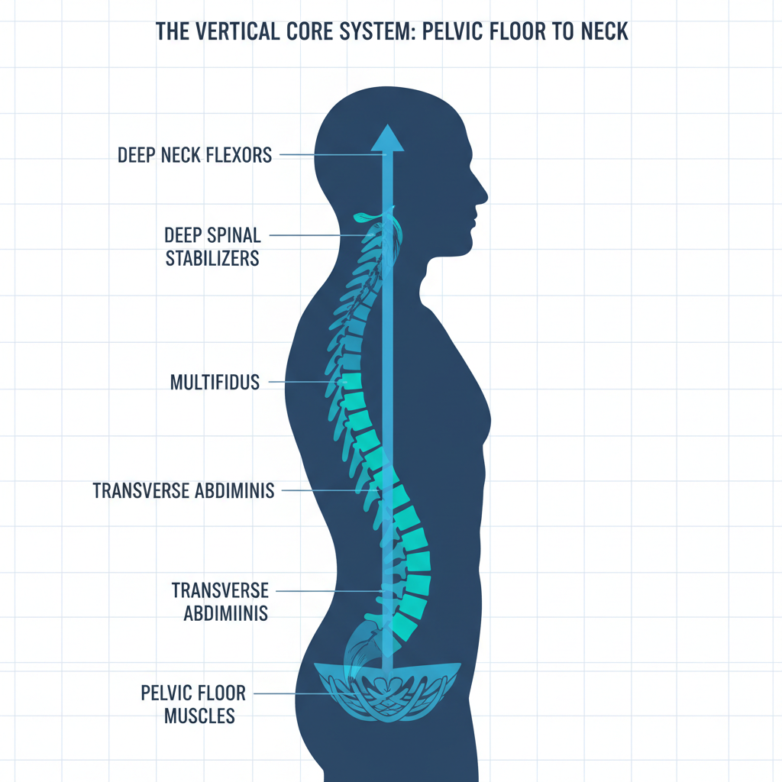
When this system works properly, your spine is protected. You can move freely. You have great posture. Pain disappears.
When it's weak or dysfunctional? That's when back pain, poor posture, limited mobility, and compensation injuries happen.
◆ ◆ ◆

2. Understanding Your Core: The Parts That Matter

It's More Complex Than You Think (But Here's the Simple Version)
Your core has three main "layers" of muscles working together:
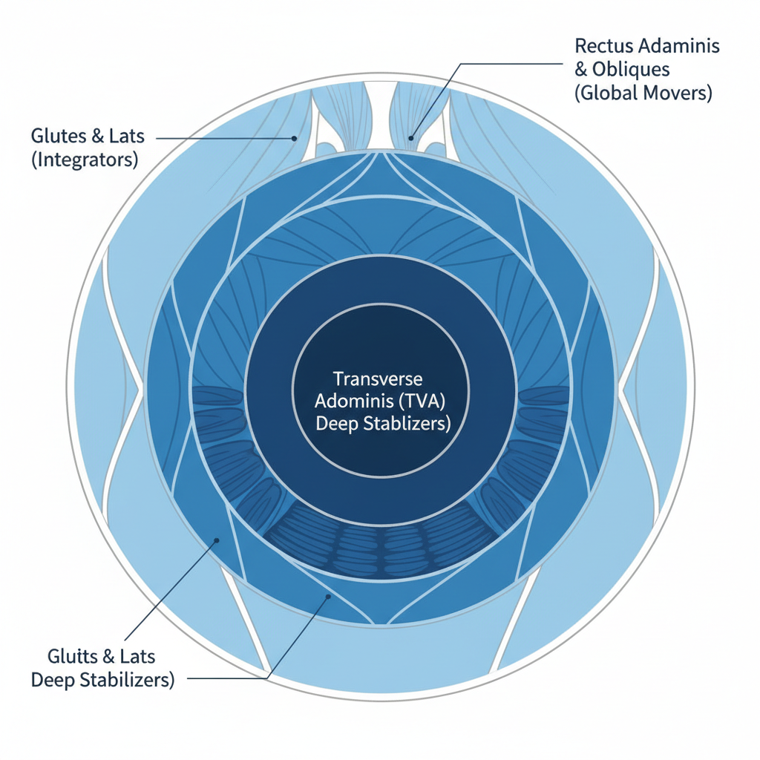
Layer 1: The Deep Stabilisers (Your Foundation)
These are the muscles you can't see. They're deep inside your body, and they're responsible for segmental stability—basically, holding each vertebra in the right place. When these muscles are weak, your spine becomes unstable, and pain follows.
Key muscle: Transverse Abdominis (TVA) — Your deepest abdominal layer. When it works properly, it creates a corset-like stability around your entire spine². This is the muscle that most people never train. Research shows that reduced activation of the TrA is linked to the incidence and progression of low back pain³.
Layer 2: The Global Movers (Your Workers)
These are the muscles you see (like your rectus abdominis and obliques). They produce force and help you move. But they only work properly when the deep stabilisers are doing their job.
Layer 3: The Integrators (Your Connectors)
These muscles (like your glutes and lats) connect your core to your arms and legs, allowing force transfer from your lower body to your upper body and vice versa. Without proper integrator function, you lose power and increase injury risk.
When all three layers work together, you have a strong, stable, resilient core. When even one layer is weak, everything else suffers.
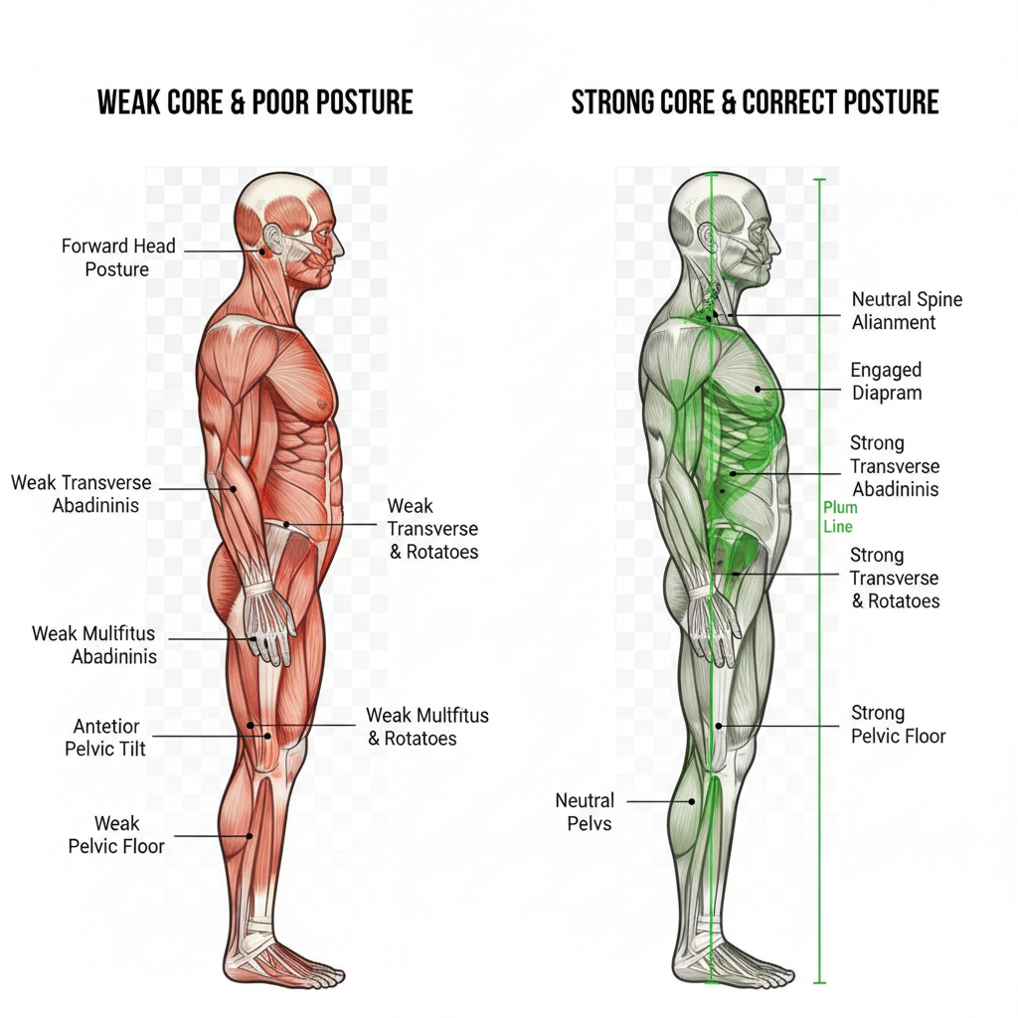

◆ ◆ ◆

3. Does Your Core Need Help? Take This Quick Test
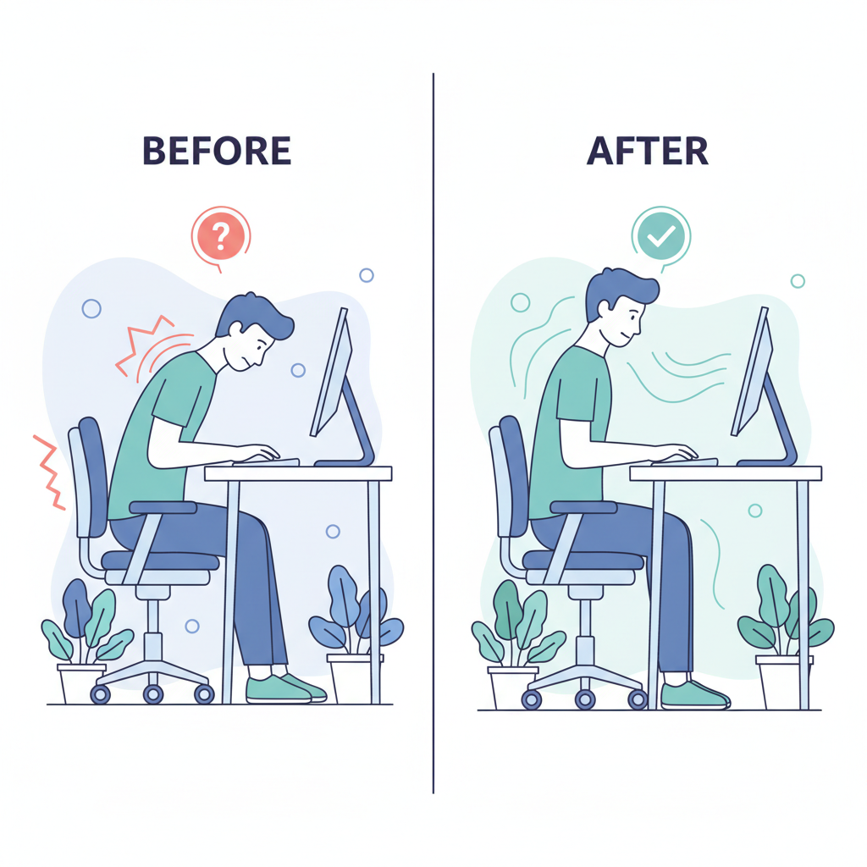
Before you invest in core training, assess whether you actually need it. Answer these questions honestly:

Quick Self-Assessment
- Do you experience back pain or stiffness, especially by the end of the day?
- Do you have poor posture? (Forward shoulders, anterior pelvic tilt, forward head position)
- Can you hold a plank for less than 60 seconds whilst maintaining neutral spine?
- Do you struggle with movements like dead bugs or bird dogs?
- Do you feel weak in your lower back or glutes during exercise?
- Do you experience pain with certain movements—bending, twisting, lifting?
- Are you avoiding activities you used to enjoy due to back or core concerns?
If you answered "yes" to three or more of these questions, your core probably needs attention. The good news? It's absolutely fixable with the right training approach.

◆ ◆ ◆

4. The Complete Core Training Solution

Why "One Workout" Doesn't Work
Real core training isn't about finding the "best" exercise. It's about a systematic progression that takes your body from unstable to strong to powerful. Most people fail because they jump straight to advanced exercises before their foundation is ready.
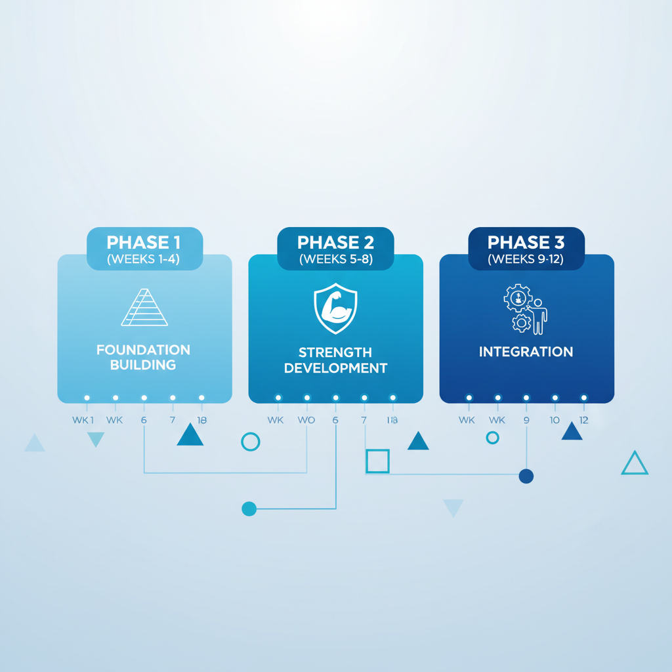

Phase 1: Building the Foundation (Weeks 1-4)
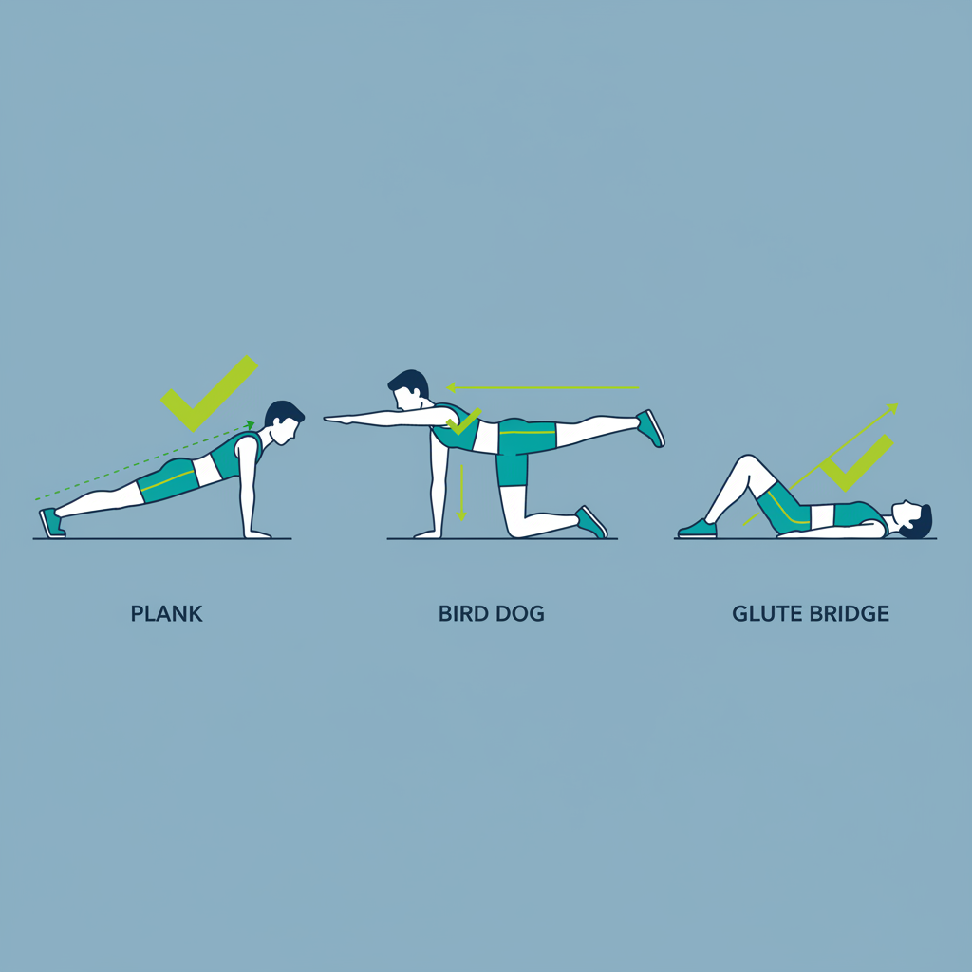
Goal: Activate deep core muscles and establish proper movement patterns. Research shows that core stability training produces significant improvements in transverse abdominis activation and timing within just 4 weeks⁶.
- Focus on mind-muscle connection—learning to feel and control deep stabilisers
- Exercises are simple: glute bridges, dead bugs, bird dogs, quadruped hip extensions
- No heavy weights. No complicated movements. Just foundational stability
- You'll start to feel improvements: better posture, less stiffness, initial pain relief
- Frequency: 3x per week
"I didn't realise my glutes weren't working at all. Within two weeks of doing these exercises, my lower back pain dropped by 50%. It's amazing how much better I feel just sitting at my desk." — Sarah, 38, Office Manager

Phase 2: Building Real Strength (Weeks 5-8)
Goal: Increase load, complexity, and unilateral (single-sided) training
- Progress to more challenging positions and add external load
- Introduction of unilateral exercises: single-leg bridges, single-leg dead bugs
- Exercises on unstable surfaces (balance pads, foam) to challenge stabilisation
- Longer plank holds with variations
- Introduction of rotational movements (Pallof press with band)
- By end of Phase 2, you've corrected imbalances and built genuine strength
"I went from avoiding the gym to actually looking forward to workouts. I can do things I haven't done in years—bending down without pain, playing with my kids without thinking about my back. This has been life-changing." — James, 45, Construction Manager

Phase 3: Integrating Into Life (Weeks 9-12)
Goal: Dynamic stability, athletic movement, real-world application
- Move beyond isolated core work—integrate with upper and lower body training
- Sport and activity-specific movements tailored to YOUR goals
- Higher loads, complex movements, real functional fitness
- By end of Phase 3, your strong core is automatic—you don't have to think about it
- Transition to maintenance: you know how to keep it strong for life
"I finished the 12-week programme and was shocked by how strong I'd become. I ran my first 5K without any back pain, something I thought was permanently off the table." — Lisa, 52, Teacher

◆ ◆ ◆

5. What Results Can You Actually Expect?

A Realistic Timeline
Timeline | What You'll Experience | Visible Results
Weeks 1-2 | Increased body awareness, initial pain reduction, better posture | Noticeable improvement in daily stiffness
Weeks 3-4 | Significant pain reduction, improved confidence with movement | Pain drops 50%+, can sit/stand longer
Weeks 5-8 | Strong strength gains, corrected imbalances, return to activities | Can resume exercise, hobbies with confidence
Weeks 9-12 | Transformation complete. Strong, stable, pain-free core | Pain gone, posture perfect, ready to maintain

Beyond Pain Relief: The Real Benefits
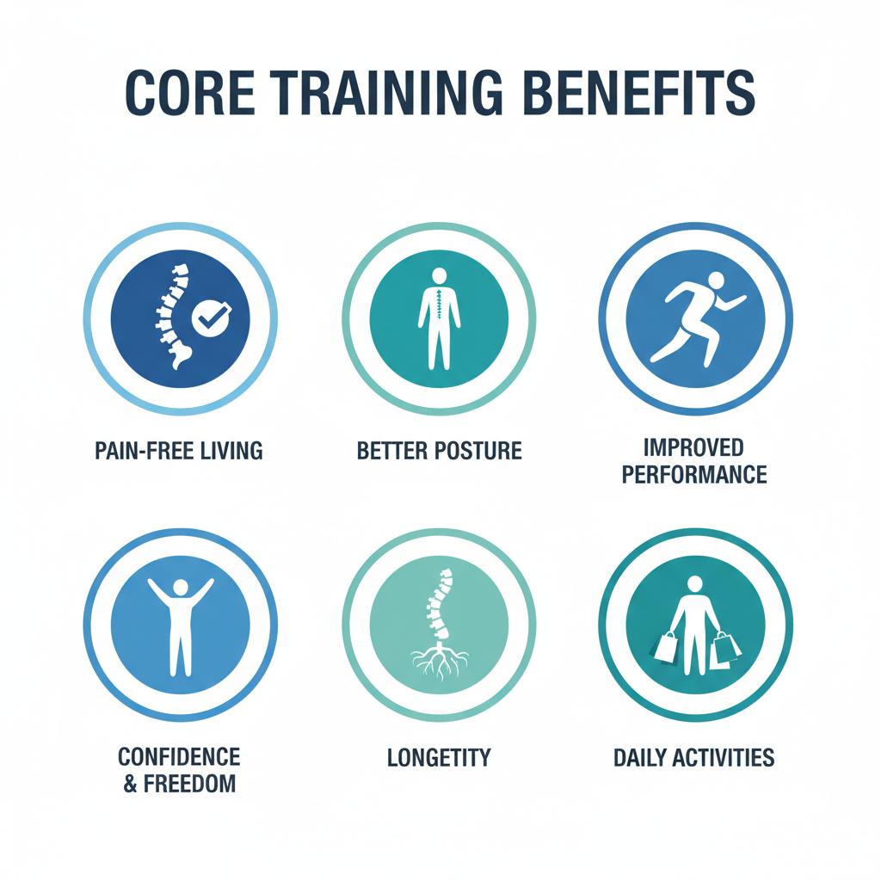
A strong vertical core gives you:
- Pain-Free Living — Back pain, stiffness, and discomfort disappear when your core is strong. Studies show core stability training is more effective than general exercise at reducing pain and improving function⁸
- Better Posture — Standing taller, looking more confident, reduced neck/shoulder pain
- Improved Performance — Whether you exercise, play sports, or just want to move better in daily life
- Confidence & Freedom — Do activities you love without fear or limitation
- Longevity — A strong, stable spine means fewer injuries, faster recovery, and long-term health
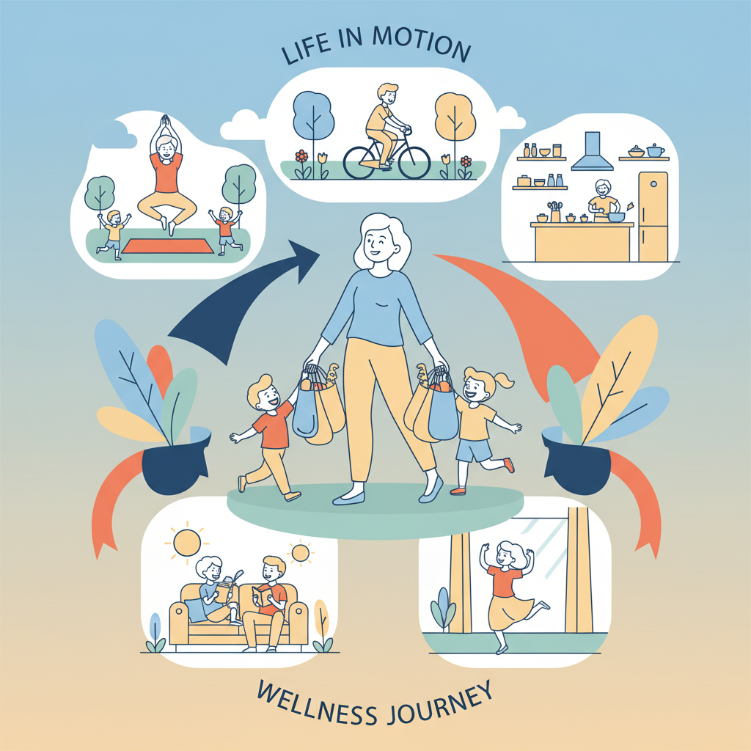

◆ ◆ ◆

6. Why Most People Fail (And How to Avoid It)

The Problem With Online Videos and DIY Programmes
You probably know that core training is important. You've probably watched YouTube videos. You've tried a few exercises at home. But here's why most people don't get results:
- No Assessment — You don't know what YOUR specific weaknesses are, so you're guessing at exercises
- Wrong Form — Small form errors compound over time and reduce results or create new injuries
- No Progression — You either do the same exercises forever or jump to advanced moves too fast
- Lack of Accountability — It's easy to skip workouts when no one is checking
- Missing the "Why" — Without understanding what you're doing and why, motivation fades

Why Personal Training Actually Works
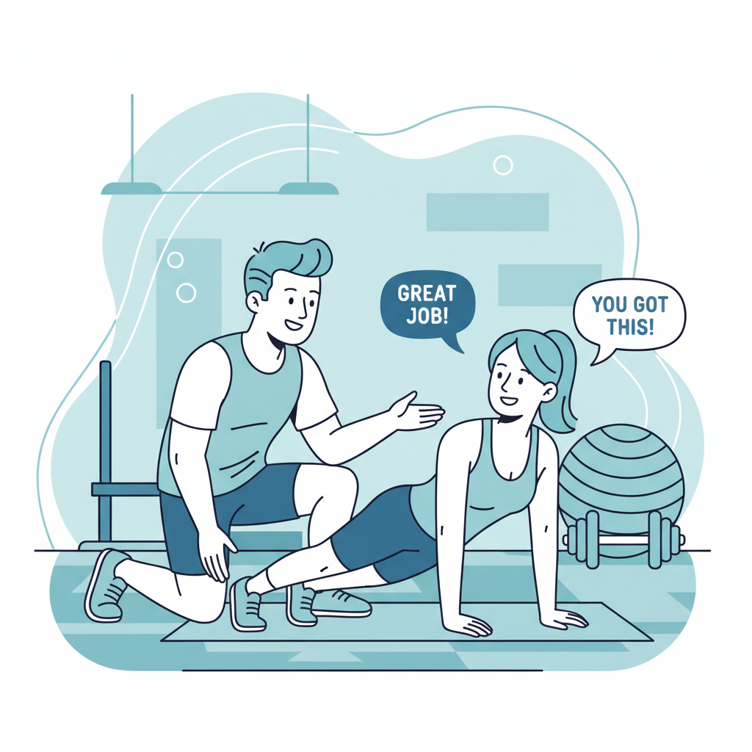
This is why working with a trained personal trainer makes the difference:
- Individual assessment identifies YOUR specific weaknesses
- Real-time form correction prevents injuries and maximises results
- Proper progression keeps you challenged but safe
- Accountability ensures you actually do the work
- Expert guidance answers your questions and keeps you motivated
- Faster results — most people see dramatic improvement within 4-6 weeks

◆ ◆ ◆

7. Your Path Forward
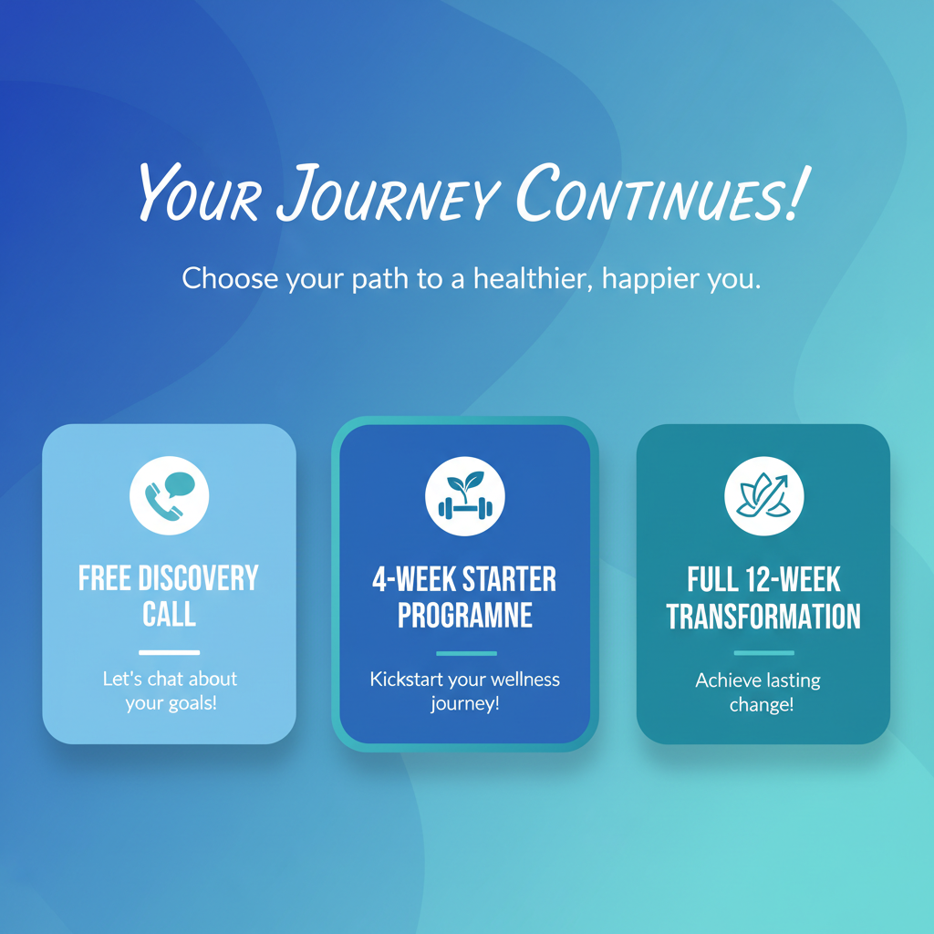

Three Powerful Options
Option 1: Free Discovery Call
Not ready to commit? Start with a free 15-minute discovery call. We'll assess your core health, identify your specific issues, and explain exactly what a training programme would look like for you. No pressure. Just information so you can make an informed decision.
Option 2: 4-Week Starter Programme
Dive straight in with our foundational core training phase. You'll get personalised assessment, a tailored exercise programme, weekly check-ins, and form correction. Most people see 50%+ pain reduction in just 4 weeks. This is the fastest way to real results.
Option 3: Full 12-Week Transformation
The complete solution. Three phases of progressive training, comprehensive assessment, integrated programming, regular progress tracking, and transformation into a fully pain-free, strong version of yourself. This is what real change looks like.

Why Now Is The Right Time
Every day you wait is another day of pain, limitation, and not living your life fully. Most people who start core training say the same thing: "I wish I'd done this sooner."
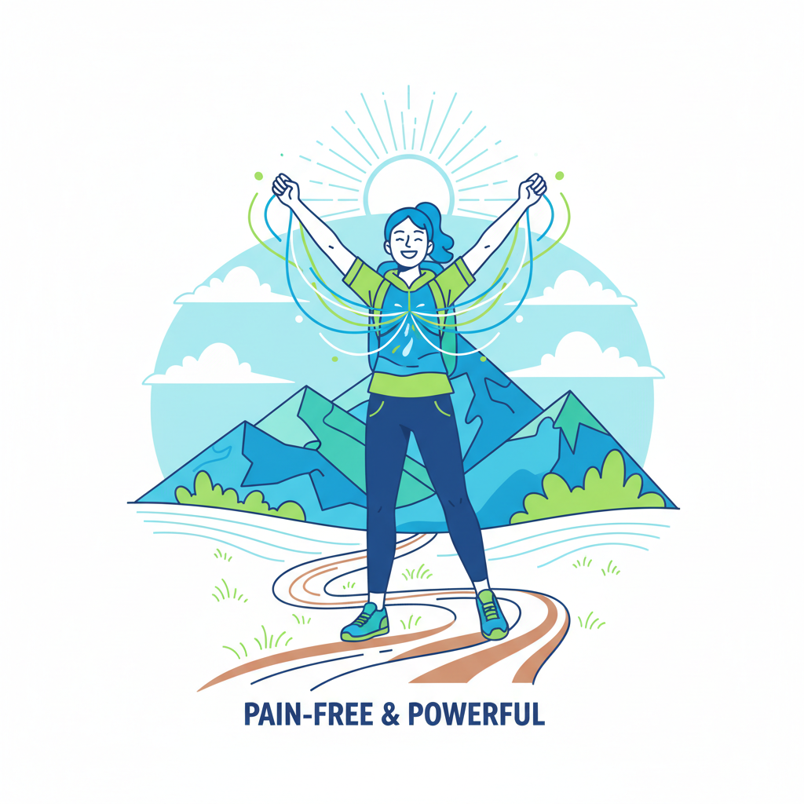
The 12-week programme starts with a single step. One call. One session. That's it.
Twelve weeks from now, you could be pain-free, strong, confident, and ready to live without limitation. Or you could be exactly where you are now—stuck, uncomfortable, holding yourself back.
◆ ◆ ◆

Ready to Transform?
Book your free discovery call today.
We'll assess your core, answer your questions, and create a personalised plan to get you pain-free and strong.
Your future pain-free self is waiting.
Don't wait another day.
◆
Contact us now to book your consultation.

◆ ◆ ◆

References
The information in this ebook is supported by peer-reviewed research and UK health statistics. Below are the key references that underpin the evidence-based approach presented throughout this guide.
1. Versus Arthritis (2019). Prevalence of back pain in England and Portsmouth. Musculoskeletal Calculator Report. Available from: https://www.versusarthritis.org [Accessed: Shows that approximately 1 in 6 adults in England have some form of back pain, and back pain is the leading cause of disability in the UK]
2. Hodges, P.W., & Richardson, C.A. (1996). Inefficient muscular stabilization of the lumbar spine associated with low back pain: A motor control evaluation of transversus abdominis. Spine, 21(22), 2640-2650. [Landmark research demonstrating the role of transverse abdominis in spinal stability]
3. Ferreira, P.H., Ferreira, M.L., & Hodges, P.W. (2004). Changes in recruitment of the abdominal muscles in people with low back pain: ultrasound measurement of muscle activity. Spine, 29(22), 2560-2566. [Research showing reduced activation of transverse abdominis is linked to incidence and progression of low back pain]
4. Shiri, R., Coggon, D., & Falah-Hassani, K. (2018). Exercise for the Prevention of Low Back Pain: Systematic Review and Meta-Analysis of Controlled Trials. American Journal of Epidemiology, 187(5), 1093-1101. [Meta-analysis showing exercise alone reduced risk of LBP by 33%, and exercise combined with education reduced it by 27%]
5. Steffens, D., Maher, C.G., Pereira, L.S., et al. (2016). Prevention of Low Back Pain: A Systematic Review and Meta-analysis. JAMA Internal Medicine, 176(2), 199-208. [Systematic review confirming exercise combined with education reduces risk of LBP episodes by 45%]
6. Selkow, N.M., Grindstaff, T.L., Cross, K.M., et al. (2017). Transversus Abdominis Activation and Timing Improves Following Core Stability Training: A Randomized Trial. International Journal of Sports Physical Therapy, 12(7), 1048-1056. [RCT demonstrating significant improvements in TrA activation and timing following 4-week core stability programme]
7. Tsartsapakis, I., Bagioka, I., Fountoukidou, F., & Kellis, E. (2024). A Comparison between Core Stability Exercises and Muscle Thickness Using Two Different Activation Maneuvers. Journal of Functional Morphology and Kinesiology, 9(2), 70. [Recent research comparing effectiveness of different core stability exercises for deep muscle activation]
8. Lim, E.C.W., Poh, R.L.C., Low, A.Y., & Wong, W.P. (2011). Effects of Pilates-based exercises on pain and disability in individuals with persistent nonspecific low back pain: a systematic review with meta-analysis. Journal of Orthopaedic & Sports Physical Therapy, 41(2), 70-80. [Evidence for progressive core training in chronic back pain management]
9. McGill, S.M. (2001). Low back stability: from formal description to issues for performance and rehabilitation. Exercise and Sport Sciences Reviews, 29(1), 26-31. [Foundational research on core stability and low back exercises]
10. Office for National Statistics (2016). Work-related musculoskeletal disorders statistics in Great Britain. UK Government Statistical Service. [Data showing 31 million work days lost in UK due to musculoskeletal problems including low back pain, costing £12.3 billion annually]
◆ ◆ ◆
Additional Evidence
This ebook also draws upon the following bodies of evidence:
- NHS and NICE (National Institute for Health and Care Excellence) guidelines on low back pain management
- Systematic reviews from the Cochrane Library on exercise for chronic low back pain
- Peer-reviewed research on motor control exercises and core stability published in leading physiotherapy and sports medicine journals
- UK Health Survey for England data on chronic pain prevalence and management
- Clinical Practice Research Datalink (CPRD) studies on back pain healthcare utilisation in the UK
Note: While this ebook provides evidence-based information, it is designed for educational purposes only. Always consult with a qualified healthcare professional before beginning any new exercise programme, especially if you have pre-existing health conditions or chronic pain.

◆
Thank You for Reading
This ebook is your first step toward a pain-free, stronger life.
◆ ◆ ◆
Ready to Take Action?
Get in touch to start your transformation today
CONTACT INFORMATION
📧 Email: info@4dbalance.com
We look forward to hearing from you and supporting your journey to a pain-free life.
◆ ◆ ◆
Your Journey Starts Now
Don't let another day go by in pain. Take the first step.
◆
© 2024 The Core Truth. All rights reserved.
This ebook is for educational purposes only.
Always consult with a qualified healthcare professional before starting any new exercise programme.

